Standard 4-Piece Panels Installation Guide (Ceiling-Height)

CONTENTS

Pre-installation Checklist & Notes

Materials & Tools Required

Standard Panel Installation Steps

ATTENTION

Read all instructions before installation to avoid damage. Installers are responsible for any breakage from handling/installation.

PRE-INSTALLATION CHECKLIST & NOTES

STORAGE

Cast marble panels are more fragile in extreme cold—handle with care. Store all materials in a heated area for at least 24 hours before installation if possible.

BLOCKING (for Grab Bars)

Install 2"x6" blocking at designated positions before wall substrate work.

Pre-drill screw holes in panels (large enough to avoid thread contact) after installation.

Tighten screws gently—over-tightening causes cracks/breakage.

INSTALLATION OVER TILE

Ensure tile is firmly attached, mold/mildew-free and clean.

Follow standard cutting/installation steps, except use only 100% silicone or cast marble adhesive.
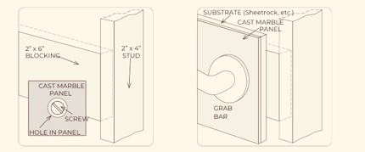
Add a 2" trim strip to cover existing tile (see diagram).

SUBSTRATE

Set shower pan/tub first, then install substrate (see Shower Pan Installation Guide).
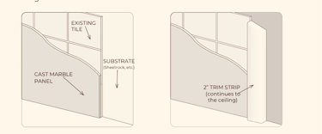
Pan/tub have leak-proof flanges—substrate must be thick enough for panels to cover flanges, sit flush with walls and not bow at the bottom.

Recommended: Moisture-resistant drywall. No waterproof membrane needed behind panels.

MATERIALS & TOOLS REQUIRED

• Cast marble adhesive (or 100% silicone + construction adhesive like PL 375/PL Premium)

• Bracing (or commercial-grade hot glue for fast fixing)

• Circular saw (masonry blade) / angle grinder (diamond masonry blade) + optional vacuum (dust reduction)

• Drill + assorted bits

• Safety mask (for cutting)

• Measuring tape

• Pencil (marks removable with acetone after installation)

• Hole saw (diamond recommended; 1¼" & 4" most common, adjust for fixtures)

• 80-grit sandpaper (bevel cut edges to prevent chipping)

• Acetone (clean marks/debris)

• Dry, clean rags

STANDARD PANEL INSTALLATION

1. Check Levelness

Pan/tub must be level (front/back, side/side, diagonal). Max tolerance: ±1/4".

Notify customer if out of tolerance before installation.

2. Establish Horizontal Control Line (HCL)

Use tile-pattern panel (12”x24”) as an example.

• Shower: Measure up from pan to grout line near 60" → subtract 1/2" → mark HCL.

• Tub: Measure up from tub to grout line near 48" → subtract 1/2" → mark HCL.

Example: Shower grout line at 60¼" → 60¼" - 1/2" = 59¾" (HCL height).

3. Measure for Back Panel Trimming

• Measure pan/tub to HCL (left/center/right) and pan/tub to ceiling (same 3 positions)

• Measure back panel width (top/center/bottom) and record all data.

• Use Panel Trimming Guide (last page) to transfer measurements to panel.

4. Prep Back Panel

• Mark panel per measurements, trim equally on both sides for centering (1/8" side tolerance for gap coverage).

• Place panel on 2"x4" lumber (on saw horses) → trim with saw/grinder.

• Support excess material (＞1/2" trim) to avoid breakage.

• Sand all cut edges (especially bottom) with 80-grit sandpaper to prevent chipping.

• Dry-fit panel to check fit → clean wall/panel front/back with acetone (remove marks/debris).

5. Adhere Back Panel

Two adhesive methods (generous application required: 1 full large tube for back panel, 1/2 tube per side panel):

Method 1 (Recommended)
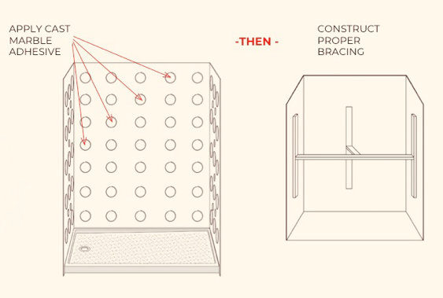

• Apply cast marble adhesive → add bracing to hold panel until cured.

• Optional: Use commercial hot glue (for flat walls/panels only) instead of bracing.

Method 2
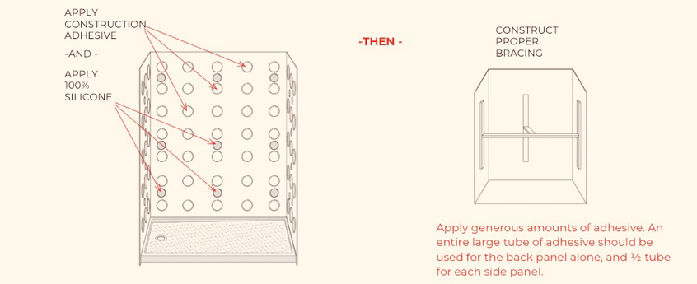
• Apply construction adhesive + 100% silicone → add bracing until cured.

6. Install Side Panels

• Transfer HCL to side walls, mark plumb line at pan/tub front edge.

• Measure & record data (per back panel steps) → mark left panel (X on factory finished edge, trim only inner edge).

• Measure plumb line to wall corner (top/center/bottom) → trim side panel width.

• Trim, sand (80-grit) → adhere with the same method as back panel.

7. Drill Plumbing Fixture Holes

• Locate holes on side panel: measure from HCL (up/down) and plumb line (left/right).

• Standard holes: 2 for shower, 3 for tub.

• Drill gently—avoid excess pressure when finishing the hole (prevents panel damage).

8. Bracing Requirement:

Build proper bracing to hold panels firmly (no excessive pressure to avoid cracks).

Add extra bracing if needed (per site conditions).

9. Caulking & Finishing

• Remove bracing after adhesive cures (24 hours typical).

• Caulk all joints:

◦ Marble-to-marble: 100% silicone.

◦ Marble-to-substrate: Paintable latex caulk.

• Max caulk joint width: 1/4". Recut panel if gap exceeds 1/4".

